17.82: (a) We can use differentials to find the frequency change because all length changes are small percents . Let m be the mass of the wire

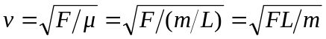
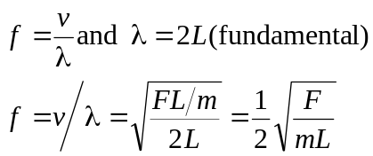
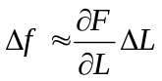 (only L changes due to heating)
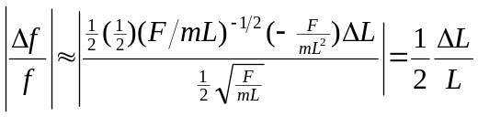

The frequency decreases since the length increases

(b) 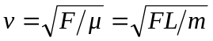
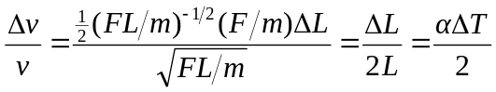
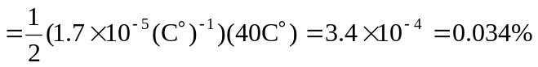
(c)
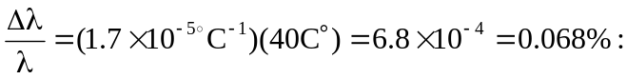
it increases

